Immunity and Disruption to Homeostasis Topic Test.

Your name_________________________________

|  |  |  |
| --- | --- | --- |
| Test part | Possible mark | Your mark |
| Multiple choice | 14 |  |
| Short answer | 30 |  |
| Extended answer | 7 |  |
| Total | 51 |  |

***Multiple choice answer sheet.***

**Use a ball point or ink pen to mark an X** on the letter that represents the best answer from the choice of answers . Marks are not deducted for wrong answers.

|  |  |
| --- | --- |
| Question | Answer |
| 1 | A B C D |
| 2 | A B C D |
| 3 | A B C D |
| 4 | A B C D |
| 5 | A B C D |
| 6 | A B C D |
| 7 | A B C D |
| 8 | A B C D |
| 9 | A B C D |
| 10 | A B C D |
| 11 | A B C D |
| 12 | A B C D |
| 13 | A B C D |
| 14 | A B C D |

1. The antibodies that a baby receives from its mothers breast milk are an example of:
2. Natural passive immunity.
3. Artificial passive immunity.
4. Natural active immunity.
5. Artificial active immunity.
6. Vaccination using attenuated antigens is an example of:
7. Natural passive immunity.
8. Artificial passive immunity.
9. Natural active immunity.
10. Artificial active immunity.

Use the diagram below to answer questions 3 and 4.

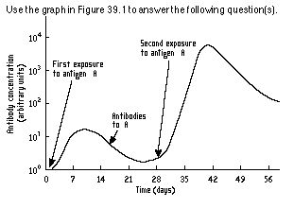

3. Why does the antibody concentration between 21 and 28 days **not** drop back to zero?

1. Memory T cells carry antibodies able to respond to antigen A.
2. Killer T cells carry antibodies able to respond to antigen A.
3. Memory B cells carry antibodies able to respond to antigen A.
4. Plasma B cells carry antibodies able to respond to antigen A.

4. The response to antigen A at 28 days would result in:

1. A rapid response and little or no symptoms of infection.
2. A reduction in T cells, but an increase in B cells.
3. Similar symptoms as seen in days 0 to 14.
4. A new set of antigens being produced.

5. The mineral often given in the treatment of Hypothyroidism is:   
  
a. Calcium.     
b. Iron.     
c. Iodine.     
d. Zinc.

6. An auto immune disorder can sometimes lead to the body’s immune system damaging the Beta cells of the islets of Langerhans. The resultant disorder is known as:   
  
a. Type 1 diabetes.     
b. Type 2 diabetes.     
c. Hypothyroidism.     
d. Hyperthyroidism.

e. Kevin the post man.

7. To help treat a person who has contracted influenza, they may be given:

1. Antiviral medication.
2. Antibiotics.
3. Flu vaccination.
4. Iodine enriched salts.

8. To make up the Influenza vaccine the influenza virus particle is added to chicken eggs. This is done repeatedly until the virus becomes adapted to infecting chickens not humans. Eventually the virus becomes unable to infect humans. This is an example of:

1. Attenuated vaccines.
2. Recombinant vaccines.
3. Dead pathogen vaccines.
4. Toxoid vaccines.

9. Agglutination can best be described as:

a. a process where antibodies cause antigens to stick together in clumps.

b. a process where antibodies cause pathogen cell membranes to break.

c. a process where macrophages engulf virus particles.

d. a process where antibodies stop virus particles replicating.

10. A body cell becomes infected by virus particles. The body would respond by:

a. sending antibodies to neutralize the virus.

b. sending Killer T cell white blood cells to attach the infected cell.

c. sending Plasma B cells.

d. sending plasma B cells to engulf jus the virus particles.

*The next question refers to the graph below of the concentration of antibodies in the blood of two patients over time after exposure to a particular disease.*



11. On the basis of the information provided in this graph,

a. patient 1 was immune to the disease they were exposed to.

b. patient 2 was probably exposed to and recovered from this disease in the past.

c. neither person would have developed memory cells on exposure to this disease.

d. the symptoms of patient 1 would have been far less severe.

12. Bob Caught a bad cold. He stayed home and rested. After a week he fully recovered, without any use of medication. This is an example of:

1. Natural passive immunity.
2. Artificial passive immunity.
3. Natural active immunity.
4. Artificial active immunity.

13. A problem for the World Health Organization (WHO) is the increasing incidence of antibiotic resistant microorganism. This increasing incidence it thought to be the result of:

a. overuse of antibiotics and natural selection.

b. underuse of antibiotics and natural selection.

c. overuse of antibiotics and international vaccination programmes.

d. the underuse of antibiotic and international vaccination programmes.

Use the diagram below to answer the questions that follow. The diagram shows the perti dish that the scientist Alexander Fleming first noticed when studying Penicillium.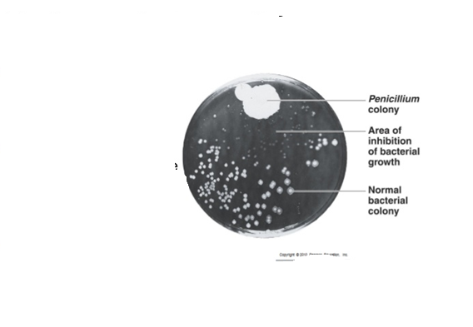

14. in this diagram:

a. Penicillium is a fungi producing an antibiotic that kills bacteria.’

b. the penicillium bacteria is being inhibited by the pathogenic bacteria.

c. the bacteria is feeding on the penicillium colony.

d. the toxins produced by the bacteria are killing the Penicillium and forcing it to grow only in one end of the petri dish.

Short Answer Section

1. Complete this table

|  |  |  |
| --- | --- | --- |
| Type of leucocyte | Where is it produced? | Where does it mature? |
| B cell |  |  |
| T cell |  |  |

1. marks)
2. Write definitions for the words in the table below.

|  |  |
| --- | --- |
| Word | Meaning |
| Antigen |  |
| Antibody |  |

(2 marks)

1. What is opsonisation?

_______________________________________________________________________________________________________________________________________________________________________________________________________________

(3 marks)

1. State two reflex responses that help the body prevent potential pathogens entering the body.

_______________________________________________________________________________________________________________________________________________________________________________________________________________________________________________________________________________________________________

(2 marks)

1. Dust containing viral particles are breathed into Kevin the Post Man’s nose. How does Kevin’s body stop the virus getting established in Kevin’s body before the need of a specific antigen response?

(6 marks)

______________________________________________________________________________________________________________________________________________________________________________________________________________________________

______________________________________________________________________________________________________________________________________________________________________________________________________________________________

______________________________________________________________________________________________________________________________________________________________________________________________________________________________

1. How are type 1 and type 2 diabetes similar and how do they differ?

(3 marks)

_________________________________________________________________________________________________________________________________________________________________________________________________________________________________________________________________________________________________________________________________________________________________________________________________________________________________________________________________________________________________

1. State 4 lifestyle behaviours that can increase a person’s chances of developing type 2 diabetes.

(4 marks)

______________________________________________________________________________________________________________________________________________________________________________________________________________________________________________________________________________________________________________________________________________________________________________________________________________________________________________________________________________________________________________________________________________________________________

1. Polio is an infectious disease caused by a virus. It infects the brain and spinal cord causing paralysis. The table below shows the number of cases of polio recorded in the USA for selected years between 1937 till 1965.

|  |  |
| --- | --- |
| Year | Number of Recorded Cases |
| 1937 | 10,000 |
| 1945 | 25,000 |
| 1953 | 57,000 |
| 1957 | 5,000 |
| 1965 | Negligible (mark as zero) |

1. Onto the grid below draw a suitable table for the information in the table. In this case it is acceptable to start the axis for the date at 1937 and end it at 1965.

(5 mark)



1. The first polio vaccine was the inactivated polio vaccine. It was developed by Jonas Salk. Between which years do you think the vaccine was first used in widespread vaccinations in the USA?

______________________________________________________________

(1 mark)

EXTENDED ANSWER QUESTION

1. Describe how the antibody mediated response to antigens occurs. Use diagrams where appropriate.

(7 marks)

__________________________________________________________________________________________________________________________________________________________________________________________________________________________________________________________________________________________________________________________________________________________________________________________________________________________________________________________________________________________________________________________________________________________________________________________________________________________________________________________________________________